**SMART FARMER IOT ENABLED SMART FARMINIG APPLICATION**

INTRODUCTION:

Farming has been the oldest sign of human civilization. Through times, we as a human find several damaging effects of our ways in growing crops to the environment including the flora and fauna. To restore the damages, people nowadays develop **smart farming with IoT**. Not only to revive nature but smart farming is designed to bring more benefits also like higher profit, efficient planting process, [premium harvest](https://refreshscience.com/piezoelectric-roads-ppt/), and others. More details are presented below.

Internet of Things includes enhanced objects with technology in processing, sensors, and more that can send and receiving data to other networks. There have been examples of IoT in daily activities like home automation to save energy, traffic control, NFC tag, etc. In agriculture, technologies also have been involved and developed for years. This is called smart farming.

The integration between technology and farmers’ skills is aimed to produce the best quality and quantity of the commodity. Humans used to take all the roles in farming from planting, growing, harvesting, checking, and so on. Yet, with smart farming, some jobs are taken over by technology including sensors, drones, [AI](https://refreshscience.com/artificial-intelligence-ppt/), and [robotics](https://refreshscience.com/basics-of-robotics-ppt/) to optimize the process and especially to ease the farmers.

Technologies in farming have been utilized in numerous ways. Each kind is installed for a different purpose. Based on the functions, here are some techniques in using technology for smart farming.

* **Field mapping or data collection:**

 Sensor technology is set up to measure environmental aspects such as humidity, temperature, light intensity, wind, water/rainfall, soil composition, and more. Then [GPS](https://refreshscience.com/what-is-5g-technology-ppt/) and GIS support the bigger picture of the map by providing the geospatial data.

* **Predictive analytics:**

 Based on data required from field mapping, several types of analytic software can predict and suggest the needed actions. Some even are equipped with alert systems of discrepancies or pest attacks.

* **Data saving:**

Using cloud-based, the regularly obtained data are uploaded as a record for future decision making. They are also shareable for wider area analytics.

* **Tracking and monitoring:**

This technique might require cameras, drones, tags, and GPS. Drones and cameras provide a visual of the field. Then, tags and GPS supply precise coordinate location of livestock.

* **Labor work:**

Similar to automation, drones, and robotics are helpful to do labor work such as planting seeds, watering the plant, harvesting, spraying the pesticides, milking the cows, picking fruits, irrigating, and more.

* **Warehousing:**

In tropical areas like India, farmers are utilizing solar-powered refrigerators to store the fruits and vegetables right on the farm. Since greens and fruits are prone to get withered, storing them in fridges directly is a smart way to provide fresh commodities.

* **Saving energy:**

Also using automation, a system could be built in the farm to cut down energy consumption. Smart irrigation could automatically turn the machine off when a sufficient amount of water in the soil is reached. Drone-spraying only on the necessary spots could prevent polluting the land.

In order to meet the current global needs of humanity, new solutions and technologies are constantly being proposed and implemented. This has led to the advent of the Internet of Things (IoT) . IoT is defined as the network of all objects that are embedded within devices, sensors, machines, software and people through the Internet environment to communicate, exchange information and interact in order to provide a comprehensive solution between the real world and the virtual world. In recent years, IoT has been applied in a series of domains, such as smart homes, smart cities, smart energy, autonomous vehicles, smart agriculture campus management , healthcare and logistics. Series of other IoT applications have been described by Shafique et al. An illustration of rich and diverse IoT applications

**Diagram**

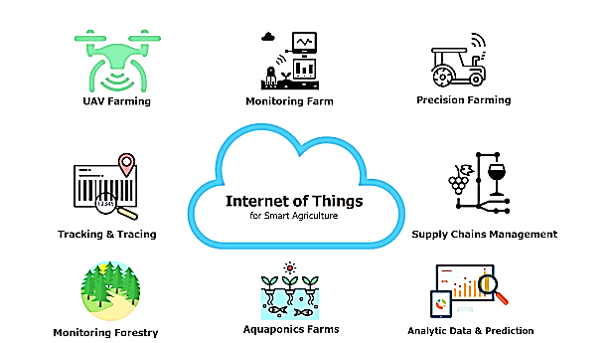

**Communication technology tabulation:**

I refered to the communication technology tabulation take the paper for Applied science from Vu Khanh Quy 1 et al , in the 1970s.

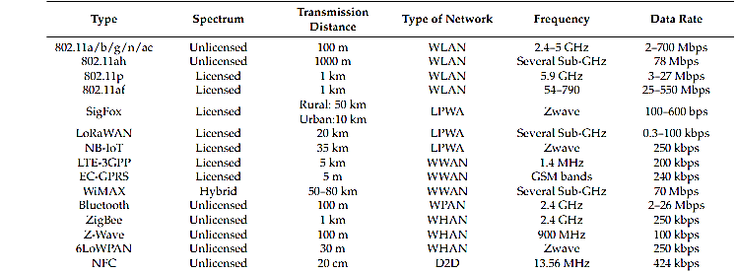

**Architecture:**

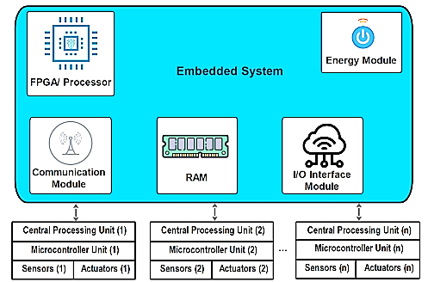

IoT Devices The common architecture of an IoT device consists of sensors to collect information from the environment, actuators based on wired or wireless connections, and an embedded system that has a processor, memory, communication modules, input–output interfaces and battery power. The common architecture of a typical IoT device for smart agriculture.

The survey of communication technologies for IoT indicated that to integrate IoT into the smart agriculture sector, communication technologies must progressively improve the evolution of IoT devices. They play an important role in the development of IoT systems. The existing communication solutions can be classified as: protocol, spectrum, and topology. Protocols: many wireless communication protocols have been proposed for the smart agriculture sector. Based on these protocols, devices in a smart agricultural system can interact, exchange information, and make decisions to monitor and control farming conditions and improve yields and production efficiency. The typical, low-power communication protocol numbers commonly used in smart agriculture can be divided into short-range and long-range categories based on the communication range. - Short-range: NFMI (near-field magnetic induction), Bluetooth, ZigBee, terahertz (Z-Wave), and RFID. - Long-range: LoRa, Sigfox, and NB-IoT (Narrowband IoT). Table 1 presents some typical communication technologies for the smart agriculture sector. The values in Table 1 indicate that short-range communication technologies have a transmission distance of less than 20 (m), high energy efficiency, and low data rate. These protocols are often employed in sensor networks, while long-range communication technologies have transmission distances of up to several tens of kilometers, consume more energy, and are installed for backhaul device-to-device communications. A diverse survey of low-power communication technologies for IoT that presents solutions, challenges, and some open issues is described by Sundaram et al.

**LITERATURE REVIEW**

**Zuraida Muhammad, et al.**[2020 10th IEEE International Conference on Control System, Computing and Engineering (ICCSCE)](https://ieeexplore.ieee.org/xpl/conhome/9203789/proceeding).The term "Internet of Things" refers to the connection of objects, equipment, vehicles, and other electronic devices to a network for the purpose of data exchange (IoT). The Internet of Things (IoT) is increasingly being utilised to connect objects and collect data. As a result, the Internet of Things' use in agriculture is crucial. The idea behind the project is to create a smart agriculture system that is connected to the internet of things. The technology is combined with an irrigation system to deal with Malaysia's variable weather. This system's microcontroller is a Raspberry Pi 4 Model B. The temperature and humidity in the surrounding region, as well as the moisture level of the soil, are monitored using the DHT22 and soil moisture sensor. The data will be available on both a smartphone and a computer.  As a result, Internet of Things (IoT) and Raspberry Pi-based Smart Agriculture Systems have a significant impact on how farmers work. It will have a good impact on agricultural productivity as well. In Malaysia, employing IoT-based irrigation systems saves roughly 24.44 percent per year when compared to traditional irrigation systems. This would save money on labour expenditures while also preventing water waste in daily needs.

**J. Divya et al.**IoT based Smart Soil Monitoring System for Agricultural Production” 2017.Agriculture is essential to India's economy and people's survival. The purpose of this project is to create an embedded-based soil monitoring and irrigation system that will reduce manual field monitoring and provide information via a mobile app. The method is intended to help farmers increase their agricultural output. A pH sensor, a temperature sensor, and a humidity sensor are among the tools used to examine the soil. Based on the findings, farmers may plant the best crop for the land. The sensor data is sent to the field manager through Wi-Fi, and the crop advice is created with the help of the mobile app. When the soil temperature is high, an automatic watering system is used. The crop image is gathered and forwarded to the field manager for pesticide advice.

**H.G.C.R. Laksiri, et al**[2019 14th Conference on Industrial and Information Systems (ICIIS)](https://ieeexplore.ieee.org/xpl/conhome/9048628/proceeding) Development of an effective loT-based smart irrigation system is also a crucial demand for farmers in the field of agriculture. This research develops a low-cost, weather-based smart watering system. To begin, an effective drip irrigation system must be devised that can automatically regulate water flow to plants based on soil moisture levels. Then, to make this water-saving irrigation system even more efficient, an IoT-based communication feature is added, allowing a remote user to monitor soil moisture conditions and manually adjust water flow. The system also includes temperature, humidity, and rain drop sensors, which have been updated to allow remote monitoring of these parameters through the internet. In real time, these field weather variables are stored in a remote database. Finally, based on the present weather conditions, a weather prediction algorithm is employed to manage water distribution. Farmers would be able to irrigate their crops more efficiently with the proposed smart irrigation system.

Anushree Math, et al Published 1 August 2018 Computer Science 2018 IEEE Distributed Computing, VLSI, Electrical Circuits and Robotics (DISCOVER)

India is a country where agriculture plays a vital role. As a result, it's critical to water the plants wisely in order to maximise yield per unit space and so achieve good output. Irrigation is the process of providing a certain amount of water to plants at a specific time. The purpose of this project is to water the plants on the National Institute of Technology Karnataka campus with a smart drip irrigation system. To do this, the open source platform is used as the system's fundamental controller. Various sensors have been employed to supply the current parameters of components that impact plant healthiness on a continual basis. By controlling a solenoid valve, water is provided to the plants at regular intervals depending on the information acquired from the RTC module. The webpage may be used to monitor and manage the complete irrigation system. This website contains a function that allows you to manually or automatically control plant watering. The health of the plants is monitored using a Raspberry Pi camera that gives live streaming to the webpage. The controller receives water flow data from the water flow sensor through a wireless network. The controller analyses this data to see if there are any leaks in the pipe. Forecasting the weather is also done to restrict the quantity of water given, making it more predictable and efficient.

**Dweepayan Mishra, et al**2019 JETIR January 2019 ISSN-2349-5162Agriculture is a substantial source of revenue for Indians and has a huge impact on the Indian economy. Crop development is essential for enhanced yield and higher-quality delivery. As a result, crop beds with ideal conditions and appropriate moisture can have a big influence on output. Traditional irrigation systems, such as stream flows from one end to the other, are usually used. As a result of this delivery, the moisture levels in the fields can alter. A designed watering system can help to enhance the management of the water system. This research proposes a terrain-specific programmable water system that will save human work while simultaneously improving water efficiency and agricultural productivity. The setup is made up of an Arduino kit, a moisture sensor, and a Wi-Fi module. Data is acquired by connecting our experimental system to a cloud framework. After then, cloud services analyse the data and take the necessary actions.

**R. Nageswara Rao, et al** January 2020 Conference: 2020 International Conference on Artificial Intelligence and Signal Processing (AISP)

"IOT based crop monitoring and automation irrigation system", 978-1-5386-0807-4/18/$31.00,IEEE (ICISC 2018).Agrarian countries like India rely heavily on agriculture for their development. Agriculture has always been a roadblock to the country's development. Smart agriculture, which comprises modernising present agricultural systems, is the only answer to this challenge. As a result, the suggested strategy attempts to use automation and Internet of Things technologies to make agriculture smarter. Crop growth monitoring and selection, irrigation decision assistance, and other uses are possible thanks to the Internet of Things (IoT). To modernise and boost crop yield, a Raspberry Pi-based autonomous irrigation IOT system has been proposed. This project's main purpose is to produce crops using the least amount of water possible. Most farmers waste a lot of time in the fields in order to focus on water available to plants at the appropriate time. Water management should be improved, and the system circuit's complexity should be minimised. Based on the data collected from the sensors, the suggested system determines the amount of water required. Two sensors detect the humidity and temperature of the soil, as well as the humidity, temperature, and length of sunshine each day, and send the data to the base station. Based on these characteristics, the recommended systems must calculate the irrigation water quantity. The key benefit of the system is the integration of Precision Agriculture (PA) and cloud computing, which will reduce water fertiliser consumption while increasing crop yields and assisting in the evaluation of field weather conditions.

**Shweta B. Saraf et al** [**IoT based smart irrigation monitoring and controlling system**](https://typeset.io/papers/iot-based-smart-irrigation-monitoring-and-controlling-system-e2jg750zmm) 19 May 2017

The Internet of Things (IoT) is the internet-based connectivity of a huge number of devices (IoT). A unique identity links each item, allowing data to be sent without human involvement It makes it possible to develop strategies for improved natural resource management. Smart gadgets with sensors, according to the IoT concept, enable interaction with the physical and logical worlds. The proposed system in this study is built on the Internet of Things and uses real-time input data. Over a wireless sensor network, a smart farm irrigation system uses an Android phone to remotely monitor and regulate drips. Between sensor nodes and base stations, Zigbee is utilised to communicate. A web-based java graphical user interface is used to process and present the server's real-time observed data. Field irrigation system wireless monitoring eliminates human interaction and enables for remote monitoring and control using an Android phone.

Cloud computing is a potential choice due to the large volume of data created by the wireless sensor network. This research presents and examines a cloud-based wireless communication system for monitoring and controlling a collection of sensors and actuators in order to determine the water needs of plants.

**Shrihari M**The concept of automating agricultural production has been around since the early 1990s, and one of the primary challenges that both scientists and farmers confront is irrigation. Irrigation is a dynamic system that is heavily reliant on outside influences. This article describes a method that uses a custom-built mathematical model to handle data from wireless sensors on Google Cloud, resulting in a smart system. An IoT-enabled design that can scale up to big farms. According to Holistic Agricultural Studies, around 35 have been damaged by animals and people. This intelligent system uses Tensor flow and deep learning neural networks to recognise animals depending on their threat level, as well as human intruders who are not authorised on the farm, and to alert the farmer immediately. An android application is included with the device, which allows for remote access and surveillance through live video streaming.

**G. Sushanth, et al**Published 22 March 2018 Computer Science 2018 International Conference on Wireless Communications, Signal Processing and Networking (WiSPNET)

Smart agriculture is a novel concept since IoT sensors can offer information about agricultural regions and then act on it based on user input. The purpose of this study is to develop a smart agricultural system that utilises cutting-edge technologies such as Arduino, Internet of Things, and wireless sensor networks. Through automation, the research tries to take use of emerging technologies such as the Internet of Things (IoT) and smart agriculture. The capacity to monitor environmental factors is a critical component in increasing crop efficiency. The purpose of this study is to develop a system that can monitor temperature, humidity, wetness, and even the movement of animals that might damage crops in agricultural areas using sensors, and then send an SMS notification as well as a notification on the app developed for the same to the farmer's smartphone via Wi-Fi/3G/4G if there is a discrepancy. The system uses a duplex communication link based on a cellular Internet interface, which allows data inspection and irrigation schedule to be changed using an android app. Because of its energy independence and inexpensive cost, the gadget has the potential to be useful in water-scarce, geographically isolated areas.

**Vaishali S et al**Published 6 April 2017 Computer Science 2017 International Conference on Communication and Signal Processing (ICCSP)

From the beginning of time, agriculture has been the most important practise in human society. Traditional irrigation methods, such overhead sprinklers and flood irrigation, are inefficient. They waste a lot of water and may even make people sick by causing fungus growth in the soil due to too much moisture. Due to the scarcity of water, an automated irrigation system is essential for water conservation and, as a result, agricultural profitability. Irrigation consumes around 85% of the world's total accessible water resources. This need is projected to increase in the coming years as the population grows. To meet this need, we must employ creative methods that lower the quantity of water utilised in irrigation. Sensors in the automated system monitor the availability of water to the crops, and watering is done as needed through controlled irrigation. Because of its practically limitless storage and processing capabilities, as well as its fast flexibility, cloud computing is an intriguing solution to the massive amount of data generated. The objective is to focus on factors like as temperature and soil moisture. This is a mobile integrated and smart irrigation system based on an Internet of Things-enabled application-controlled monitoring system. The main purpose of this project is to regulate the water supply and monitor the plants using a Smartphone.

Hamza BENYEZZA et al January 2020 Conference: 2020 International Conference on Artificial Intelligence and Signal Processing (AISP)

Water management currently global problem to all of us to tackle them in near future we need to plan it smartly. As we are living in modern world filled with lots of useful sensors from which we can designed systems with water saving capabilities. The work in this paper is focusing on increasing effective use of water using field assist to farmer. Basically it works with soil moisture sensor which gives finding of moisture level in soil and reconnects with Thing Speaks cloud via Wi-Fi module ESP8266 to observation of soil conditions. Proposed system also set with an algorithm such that on soil moisture pattern data it can predict decision on irrigation of crops. system also warns farmer about empty water source if it occurs . benefits of using this system also includes weather prediction through website. The device has the potential to be beneficial in water-scarce, geographically isolated places due to its energy independence and low cost. The fact that the technology is simple to use for farmers adds to its utility. It also saves water by preventing waste.

**Shiny Rajendrakumar, Prof et al** 2019 JETIR January 2019 ISSN-2349Agricultural Irrigation is very important for the production of crops. Many methods have developed to save water in different ways. In traditional irrigation systems we require an operator or farmer to put water on crops but he does not come to know which crop require how much amount of water to get proper amount of yields. Irrigation means planting the crops by water. There are so many traditional irrigation methods, but all these methods consume large amount of water. Automated irrigation is the method which saves the water from up to 97% as compared to traditional methods. By using these modern methods like ICT productivity can be improved without unnecessary wastage of water. Here we are concentrating on loT ie.

**Summery:**

In this study, we presented an overview of IoT and big data for the smart agriculture sector. Several issues related to promoting IoT deployment in the agriculture sector have been discussed in detail. Survey results indicate that many studies have been performed to apply IoT for smart agriculture, aiming to enhance productivity, reduce human labour, and improve production efficiency. The benefits of applying IoT and big data in agriculture were discussed. In addition, we also pointed out the challenges we need to overcome to be able to accelerate the deployment of IoT in smart agriculture